clear
clc
w = 0:0.01:20;
w = 1j*w;
z = [3 1.5 1 0.8 0.6 0.4 0.2]
z =
3.0000 1.5000 1.0000 0.8000 0.6000 0.4000 0.2000
Wn = 1;
figure()
hold()
for i = 1:numel(z)
H = (Wn^2)./(w.*w + Wn^2 + w.*2*z(i)*Wn);
plot(real(w/1j),abs(H),'Linewidth',2)
end
xlabel('Frequency')
ylabel('Gain')
legend('Zeta = 3','Zeta = 1.5','Zeta = 1','Zeta = 0.8','Zeta = 0.6','Zeta = 0.4','Zeta = 0.2')
title('Frequency response for Wn = 1')
figure()
hold()
for i = 1:numel(z)
H = (Wn^2)./(w.*w + Wn^2 + w.*2*z(i)*Wn);
plot(real(w/1j),phase(H)*180/pi,'Linewidth',2)
end
xlabel('Frequency')
ylabel('Phase')
legend('Zeta = 3','Zeta = 1.5','Zeta = 1','Zeta = 0.8','Zeta = 0.6','Zeta = 0.4','Zeta = 0.2')
title('Frequency response for Wn = 1')
Current plot held
Current plot held
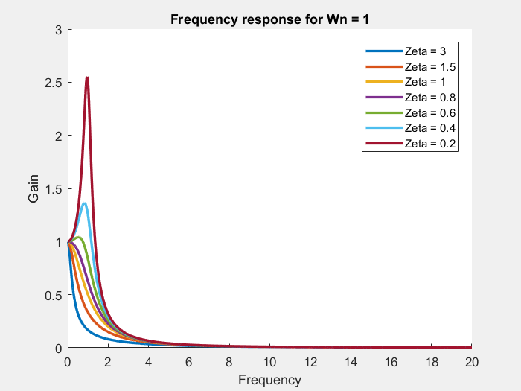
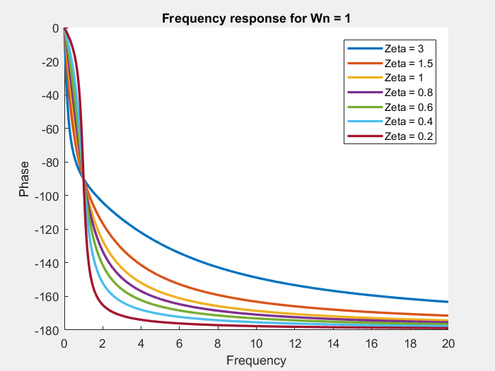
Wn = 5;
figure()
hold()
for i = 1:numel(z)
H = (Wn^2)./(w.*w + Wn^2 + w.*2*z(i)*Wn);
plot(real(w/1j),abs(H),'Linewidth',2)
end
xlabel('Frequency')
ylabel('Gain')
legend('Zeta = 3','Zeta = 1.5','Zeta = 1','Zeta = 0.8','Zeta = 0.6','Zeta = 0.4','Zeta = 0.2')
title('Frequency response for Wn = 5')
figure()
hold()
for i = 1:numel(z)
H = (Wn^2)./(w.*w + Wn^2 + w.*2*z(i)*Wn);
plot(real(w/1j),phase(H)*180/pi,'Linewidth',2)
end
xlabel('Frequency')
ylabel('Phase')
legend('Zeta = 3','Zeta = 1.5','Zeta = 1','Zeta = 0.8','Zeta = 0.6','Zeta = 0.4','Zeta = 0.2')
title('Phase response for Wn = 5')
Current plot held
Current plot held
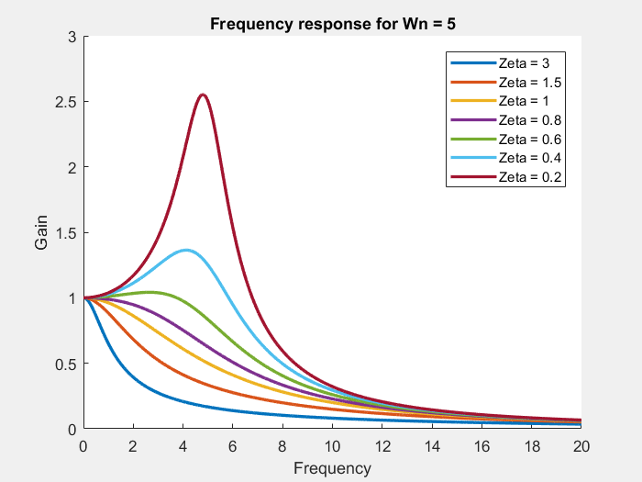
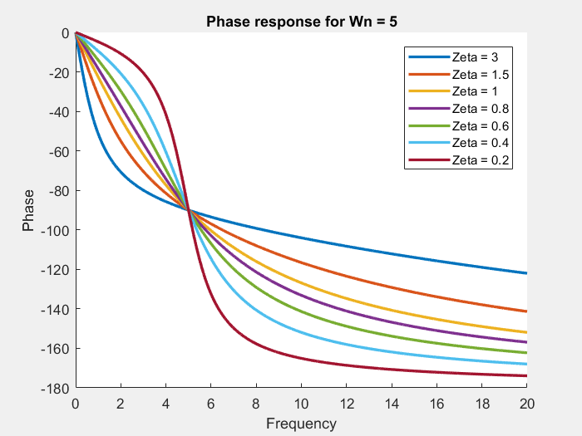
Wn = 10;
figure()
hold()
for i = 1:numel(z)
H = (Wn^2)./(w.*w + Wn^2 + w.*2*z(i)*Wn);
plot(real(w/1j),abs(H),'Linewidth',2)
end
xlabel('Frequency')
ylabel('Gain')
legend('Zeta = 3','Zeta = 1.5','Zeta = 1','Zeta = 0.8','Zeta = 0.6','Zeta = 0.4','Zeta = 0.2')
title('Frequency response for Wn = 10')
figure()
hold()
for i = 1:numel(z)
H = (Wn^2)./(w.*w + Wn^2 + w.*2*z(i)*Wn);
plot(real(w/1j),phase(H)*180/pi,'Linewidth',2)
end
xlabel('Frequency')
ylabel('Phase')
legend('Zeta = 3','Zeta = 1.5','Zeta = 1','Zeta = 0.8','Zeta = 0.6','Zeta = 0.4','Zeta = 0.2')
title('Phase response for Wn = 10')
Current plot held
Current plot held
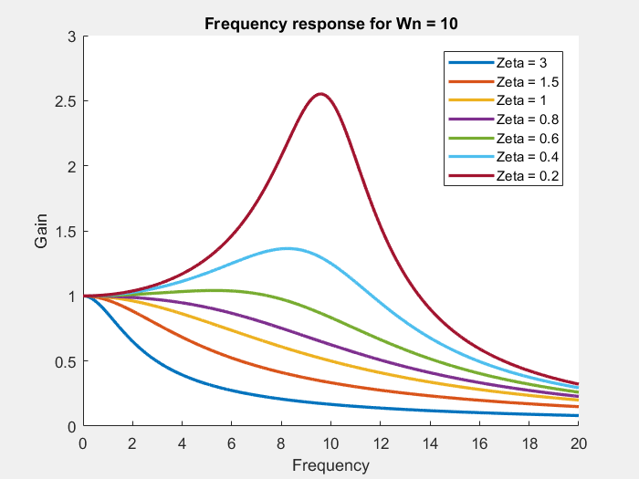
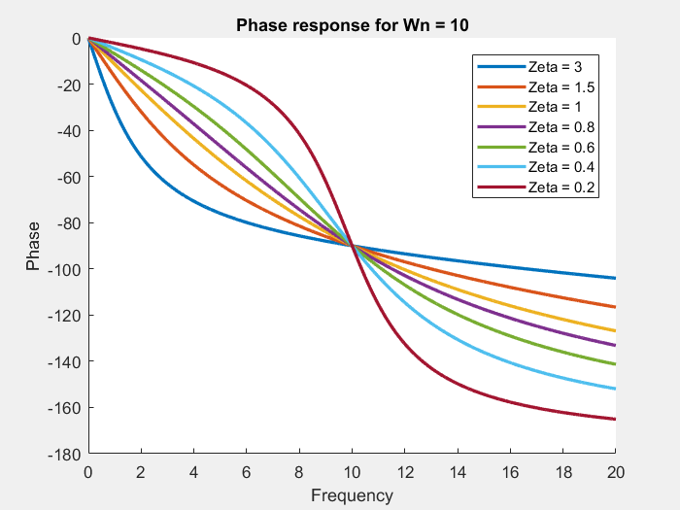
clear
clc
Published with MATLAB® R2017a

